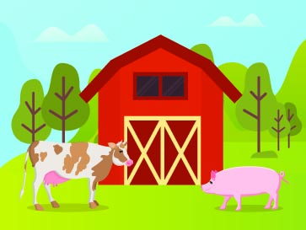
Why We Raise Pigs
Sask Pork

Suggested Questions for Classroom Discussion:
- Have you ever visited a farm and seen farm animals?
- Where does our food come from?
- Name some foods that come from plants.
- Name some foods that come from animals
- Where are farms? Cities? Rural areas? Use Google Earth (3D view) to visually show students the difference between urban and rural landscapes.
- What do you think a farmer’s job is like? Do you think it’s a hard job?
- Would you like to be a farmer or work with animals one day?
- Why do we raise pigs inside barns?
- How many piglets will a sow have in one litter?
- What do pigs eat?
- What foods are made from pork?
- What do farmers do with the pig manure?
Additional Resources:
Sask Pork - How Pigs are Raised
Agriculture in the Classroom - Snap Ag Factsheets
Farm and Food Care Saskatchewan - Real Dirt on Farming

